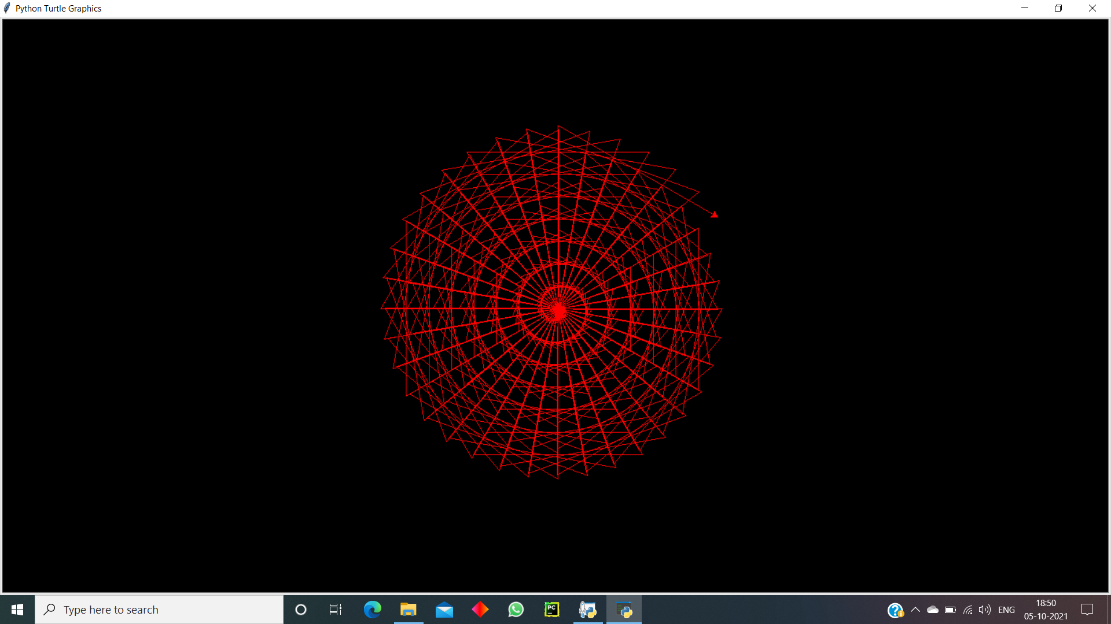

CODE:

|  |
| --- |
| import turtle as t |
|  | t.bgcolor('black') |
|  | t.color('red') |
|  | t.speed(0) |
|  | for i in range(270): |
|  | t.forward(i) |
|  | t.right(130) |
|  | t.setpos(0 , 0) |
|  | t.right(120) |
|  | t.forward(i) |
|  | t.right(120) |